TITLE: Sensory Barrage Stimulation is effective in reducing elbow spasticity: a cross over double blind randomized pilot trial
Martin Slovak ¹, Joseph Chindo ², Dr Krishnan Padmakumari Sivaraman Nair ³, Mark L. Reeves ¹, Ben Heller PhD ⁴, Professor Anthony T. Barker ¹
¹ Department of Medical Physics & Clinical Engineering, Royal Hallamshire Hospital, Sheffield Teaching Hospitals NHS Foundation Trust, Glossop Road, Sheffield, S10 2JF, United Kingdom
² Department of Neuroscience, 385A Glossop Road, Sheffield, S10 2HQ, United Kingdom
³ Department of Neurology, Royal Hallamshire Hospital, Sheffield Teaching Hospitals NHS Foundation Trust, Glossop Road, Sheffield, S10 2JF, United Kingdom
⁴ Faculty of Health and Wellbeing, Sheffield Hallam University, A129 Collegiate Hall, Collegiate Crescent, Sheffield, S10 2BP, United Kingdom

Disclaimers: Authors state that the views expressed in the article are their own
Source of support: University of Sheffield, NIHR Devices for Dignity Healthcare Technology Co-operative

Corresponding author: Dr Sivaraman Nair, Department of Neurology, Royal Hallamshire Hospital, Sheffield Teaching Hospitals NHS Foundation Trust, Glossop Road, Sheffield, S10 2JF, United Kingdom, tel.: 0114 27 12769 email: siva.nair@sth.nhs.uk
Word count: 3126
Word count abstract: 261
Number of figures: 4
Number of tables: 3
Conflict of interest: Authors declare that there is no conflict of interest.
Acknowledgements: We would like to thank University of Sheffield for providing funding for trial. Martin Slovak is a researcher associate in NIHR Devices for Dignity HTC.

Abstract
Objective: To assess the feasibility of using a novel form of multi-channel electrical stimulation, termed Sensory Barrage Stimulation (SBS) for the treatment of spasticity affecting the elbow flexor muscles and to compare this with conventional single-channel TENS stimulation.
Design: A crossover double blind randomized trial
Setting: A neurology and neurorehabiliation unit at a hospital unit
Participants: Patients with spasticity of the flexor muscles of the elbow-of grade 2 or above on the Modified Ashworth Scale (MAS).
Interventions: The participants received two intervention sessions, one week apart in a randomised order. The 60 minute stimulation was applied over the triceps brachii on the affected arm.
Main Outcome Measures: Spasticity was measured using the MAS. Secondary outcome measures were self-reported change in spasticity, measured on a visual analogue scale (VAS), and therapist-rated power of elbow extension (PEE) and flexion (PEF). The measures were taken immediately before each intervention was applied, immediately after and one hour after the intervention.
Results: Immediately after the stimulation finished spasticity showed significant reduction on the MAS and VAS for both TENS and SBS. This effect continued for the SBS at one hour after the stimulation, but not for the TENS when assessed by MAS. Although, the patient’s perception as recorded with VAS continued to show a significant change in TENS. Altogether seven SBS responders in comparison to four in the TENS group were identified.
Conclusions: This study demonstrates the feasibility and practicality of applying the new concept of sensory barrage stimulation. Promising results indicate a reduction in spasticity immediately after stimulation that persists for at least one hour.

Key Words: electrical stimulation, spasticity
Abbreviations: MAS - Modified Ashworth Scale, PEE - Power of Elbow Extension, PEF - Power of Elbow Flexion, SBS – Sensory Barrage Stimulation, TENS – Transcutaneous Electrical Nerve Stimulation, VAS – Visual Analogue Scale

Introduction
Spasticity is a disorder of sensorimotor control, resulting from an upper motor neurone (UMN) lesion and presenting as intermittent or sustained involuntary activation of muscles . It can interfere with functional recovery and lead to contractures, which impact significantly on patients’ everyday living activities. Spasticity is difficult to treat, current pharmacological agents, such as baclofen, tizanidine, dantrolene, benzodiazepine and gabapentin, have demonstrated some effectiveness , however they are often not well tolerated due to their side effects such as weakness, dizziness and drowsiness. Botulinum toxin injection is effective in reducing focal plasticity, but there is no evidence that it improves functional activity . The non-pharmacological approaches such as muscle vibration, extracorporeal shock wave therapy, various forms of magnetic or electrical stimulation have been tried in the treatment of spasticity . However there is insufficient evidence to justify using these modalities routinely .
This paper focuses on the use of two different types of electrical stimulation and studies the effect on spasticity of two variants of transcutaneous electrical nerve stimulation (TENS).
The TENS typically uses a single pair of electrodes placed on the skin at the affected site and delivers a continuous stream of repeated electrical stimuli below the level which causes muscle contraction. TENS applied to the sural nerve was reported to reduce spasticity in patients with hemiplegia . Similar effects were noted in patients with spinal cord injury immediately after 60 min of 100Hz stimulation using TENS . Several long term studies showed promising results , although a study with multiple sclerosis patients did not demonstrate reduction of spasticity but helped to reduced pain.
It has been proposed that the TENS reduces spasticity by a modulation of spinal inhibitory circuits or those of the central nervous system .
We hypothesise that the effects of TENS on spasticity can be enhanced with a new form of stimulus delivery that has two distinct features. Firstly, we hypothesise that it would be beneficial to stimulate a larger area of skin and hence more sensory fibres. It would be possible to target a larger area of tissue/nerve structures by using larger electrodes. However the stimulus current density could not be guaranteed to be distributed evenly over the electrode and, in particular, would be expected to be greater at the edges of the electrode . Instead we used a modified 64-channel, constant current, programmable electrical stimulator previously developed for use in foot drop therapy which allowed us to deliver the stimuli over a larger area compared to TENS. Our second hypothesis was that the participants may get habituated to the constant stimulation delivered through TENS between two fixed sites and thus for it become less effective with time. Perez et al. (2003) noted that patterned sensory stimulation is more effective in inducing plasticity in reciprocal 1a sensory inhibition in comparison to monotone stimulation . Therefore to further enhance the effects of TENS we have also created an intermittent pattern of stimuli which mimics a sensation of movement (stroking) over the electrode array. We have termed this type of stimulation “Sensory Barrage Stimulation” (SBS).
The aim of this pilot trial was to assess the feasibility of using SBS for the treatment of spasticity affecting the elbow flexor muscles and to compare this with conventional TENS stimulation applied between two electrodes.

Methodology
The study was approved by the regional ethics committee. Between March and June 2013 seventeen potential participants, with spasticity of the flexor muscles of the elbow-of grade 2 or more on the Modified Ashworth Scale (MAS) , were identified from the Neurology clinics at the Royal Hallamshire Hospital Sheffield.
The study was designed as a crossover double blind randomized trial. The potential participants were provided with an information sheet and contacted two weeks later. If they decided to participate in the study they were invited to attend two study visits spaced one week apart. At the first visit the participants were screened for inclusion and exclusion criteria (table 1) and gave their informed consent. The eligible participants were randomized into one of two groups. Group 1 underwent SBS at their first study visit and TENS one week later. Group 2 underwent the same interventions in the opposite order, TENS first and SBS one week later. Both interventions were applied for 60 minutes at a level just below the threshold for motor contraction. The intensity was gradually increased until a visible motor contraction was observed and then decreased to a level when it just ceased. If this level could not be achieved due to discomfort, then the strongest comfortable intensity was used.

Table 1 Inclusion and exclusion criteria
Inclusion criteria
1) | Man or Woman aged 18 and above
2) | Experiencing spasticity at elbow of grade-2 or more on the modified Ashworth scale
3) | Stable neurologically for 6 months
Exclusion criteria
1) | Some form of cognitive impairment that would interfere with their ability to comply with the experimental protocol or provide informed consent
2) | Suffered any dermatological, rheumatologic or orthopaedic complications that might interfere with the stimulation of the affected arm
3) | Pre-existing severe cardiovascular disease; active cancer or renal disease; end stage pulmonary or cardiovascular disease; psychiatric illness including severe alcohol or drug abuse and depression
4) | Inability to perform the baseline assessments
5) | Severe tactile hypersensitivity as assessed by a non-stimulation approach
6) | Participation in other, spasticity related studies
7) | Neurological deterioration in 6 months
SBS was delivered using the ShefStim; a 64-channel programmable electrical stimulator . During stimulation ShefStim was connected to a laptop and controlled via in-house produced software. The stimulator interface consisted of an 8x8 array of 8x8mm square electrodes (with a 3mm gap between each electrode) on a flexible printed circuit board. The overall dimension of the electrode array was 91x91mm. An adhesive hydrogel sheet ST GEL-high impedance grade SCBZAB-05M (Sekisui Plastics, Japan) with resistivity of 1.3 kΩ*m and thickness of 0.5mm was laid over the surface of the electrodes array to act as the interface between the electrodes and the skin . The design of the moving SBS pattern is shown in figure 1. For SBS the electrode array was divided into the eight strips (each eight electrodes long). Each individual strip was activated for approximately 0.3s with a burst of fifteen 250µs current pulses at 50Hz applied simultaneously to all electrodes in the strip. The next strip was then activated while the previous one deactivated and this cycle was repeated until the last strip had completed its sequence of stimulation pulses. This was followed by a pause of approximately 2.5s, when no current was delivered. In combination this provided a pattern mimicking the sensation of stroking the arm from proximal to distal part vertical stroking. The pulse repetition rate of 50Hz, and the on/off periods were chosen because, in pilot studies, they gave the most convincing subjective sensation of stroking. All electrodes delivered the same current and this was adjusted by the operator according to each individual participant’s motor threshold.
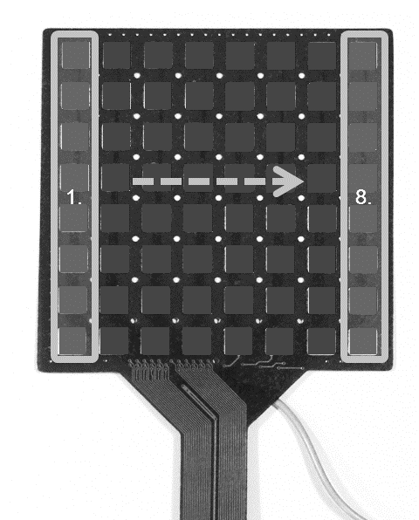

Figure 1 Photo of the array used for SBS. The activation sequence of the 8 strips of electrodes used for the SBS sequence is superimposed on the image.
TENS was delivered using a commercial stimulator (Multi-TENS, NeuroTrac, VerityMedical Ltd., UK). The parameters of the stimulation were set as a pattern stimulation with pulse repetition of 100Hz according to previous studies and 250µs pulse width with an “on phase” of 6s including a 1s rising edge ramp, a 1s falling edge ramp and a 4s “off phase” in which no current was delivered. To mimic the physical setup of SBS and to blind participants to which system was being applied, the cathode electrode (50x50mm, VS50, VerityMedical Ltd., UK) was placed centrally underneath the array used for SBS stimulation. This electrode was connected to the TENS stimulator. The participants were not informed as to which type of stimulation they received.
The arrays (both for SBS and TENS) were placed on the middle of the triceps brachii on the dorsal aspect of the affected arm and strapped with a cohesive bandage to ensure consistent contact between the electrode and the skin (figure 2). An anode electrode (100x50mm, VS10050, VerityMedical Ltd., UK) was placed proximally on the deltoid muscle of the shoulder on the same arm for both types of stimulation.
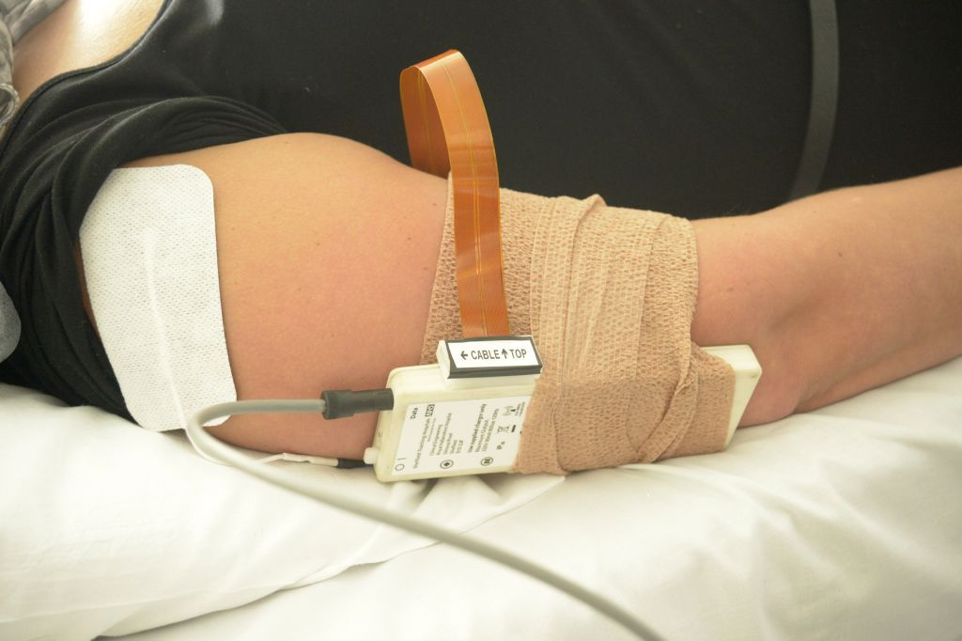
Figure 2 Position of the sensory barrage stimulator on the left elbow.
The primary outcome metric was the Modified Ashworth Scale (MAS) at the elbow . Secondary outcome measures used were power of elbow extension (PEE) and flexion (PEF) based on Medical Research Council grades and a Visual Analogue Scale (VAS) of the perceived effect on spasticity rated by the participant on a 13cm long line with the left end being the worst imaginable spasticity and right end being no spasticity. VAS was subsequently normalized to percentage where 0% represented the participant experiencing no spasticity and 100% representing the worst spasticity they could envisage. The participants who had a reduction in spasticity of at least one grade on the MAS when combined with a 30% decrease of spasticity relative to the baseline value on the VAS was considered to be a clinically significant improvement. The clinical assessments were performed by the same clinician throughout the study. The clinician was blinded about the intervention applied to the participant.
The assessment protocol was the same for both the SBS and TENS study visits. Participants were assessed before the stimulation was applied, immediately after stimulation and one hour after the stimulation was finished.
Baseline data were compared with those immediately and one hour after the interventions using the Wilcoxon signed rank test because of the non-parametric nature of the outcome measures. TENS and SBS were compared using the Mann-Whitney’s test at each assessments periods. GraphPad Prism version 6.00 for Windows (GraphPad Software, San Diego California USA) was used for the analyses. All analyses was performed using intention to treat.

Results
We approached 17 patients, among which 10 consented to take part in the study. Four others did not wish to participate, two were not able to participate due to problems with transport and one had an implanted device - an exclusion criteria for the study (figure 3). Among the 10 recruited participants there were five men and five women). Their age ranged from 18 to 65 years (40±17 years). The aetiology of spasticity was: cerebral palsy (4), stroke (3), traumatic brain injury (2) and multiple sclerosis (1). The duration of spasticity symptoms varied from six to 38 years. All tolerated the interventions well and completed the study. The retention rate was 100%.
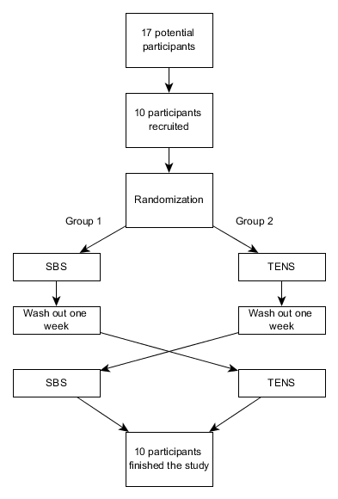
Figure 3 Study flow diagram
Across all participants the average current during a pulse was in the range of 8 to 16mA with a mean of 10.9±2.2 mA (mean ± SD) for TENS (excluding the ramp period) and the average total current from the eight simultaneously activated SBS electrodes was in the range of 7.2 to 15.2mA with a mean of 12.9±2.5mA.
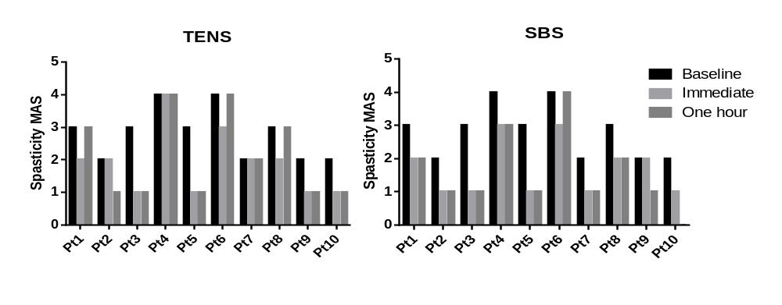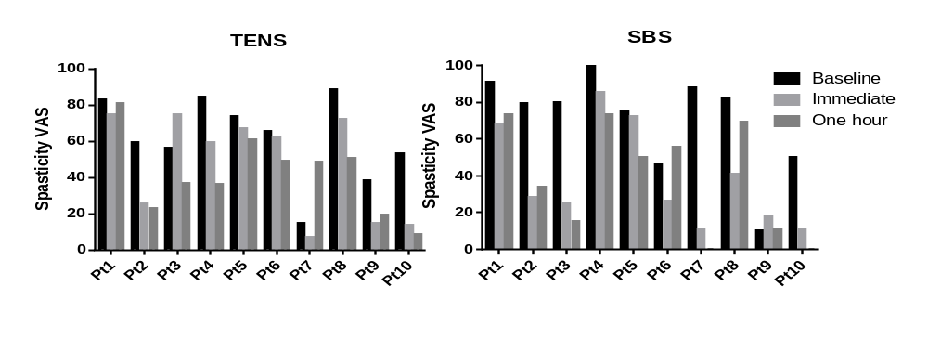
Figure 4 Spasticity MAS and VAS for each participant at baseline, immediately after and one hour after the intervention finished for both types of stimulation
A summary of the clinical outcome measures for spasticity MAS and VAS in each participant are shown in figure 3. A reduction in spasticity of at least one grade on the MAS when combined with a 30% decrease of spasticity relative to the baseline value as assessed by the participant using the VAS was considered to be a clinically significant improvement. Immediately after TENS there were 2/10 responders and after SBS in 6/10 participants (table 1). One hour after the interventions, these effects persisted in both TENS responders and in four of SBS responders, however two additional TENS and one additional SBS participants fulfilled the criteria of clinically significant improvement at this point and were considered as responders as well.
Table 2. Participants showing clinically significant improvement versus treatment and time (✓ = responder, - = non-responder).
Pt no. | TENS |  | SBS
Pt no. | Immediate | 1 hour | Immediate | 1 hour
1 | - | - | - | -
2 | - | ✓ | ✓ | ✓
3 | - | ✓ | ✓ | ✓
4 | - | - | - | -
5 | - | - | - | ✓
6 | - | - | ✓ | -
7 | - | - | ✓ | -
8 | - | - | ✓ | ✓
9 | ✓ | ✓ | - | -
10 | ✓ | ✓ | ✓ | ✓
The overall comparison of both interventions is summarised in Table 2. Immediately after the stimulation the MAS showed significant reduction for both TENS (p = 0.016) and SBS (p = 0.0039). The VAS also reduced significantly for both TENS (p = 0.027) and SBS (p = 0.0059). At one hour after the stimulation with TENS, there was no significant change in MAS compared to base line (Table 2). However, the patient’s perception as recorded with VAS continued to show a significant change. One hour after SBS a significant reduction in spasticity both on the MAS and VAS was noted. There was not a statistically significant difference between TENS and SBS immediately after (p = 0.63) and one hour after (p = 0.063) stimulation in the MAS score. However A trend was noted for a better response with SBS at one hour after the stimulation compared to TENS. There were no significant changes in the MRC grades of elbow flexion and extension with TENS and SBS (Table 3). Adverse events reported after SBS were one case of muscle spasm and one of an ache localised over the triceps muscle. One participant reported experiencing a sensation of pins and needles over his little finger after TENS.
Table 3. Summary of outcomes (mean ± SEM) with P values of Wilcoxon test comparing the baseline values with immediate and one hour after the treatment in both type of the treatment.
 | TENS |  |  | SBS
 | Baseline | Immediate | One hour | Baseline | Immediate | One hour
Spasticity Modified Ashworth Scale [-] | 2.8 ± 0.2 | 1.9 ± 0.3 | 2.1 ± 0.4 | 2.8 ± 0.2 | 1.7 ± 0.3 | 1.6 ± 0.4
Spasticity Modified Ashworth Scale [-] |  | (p = 0.016) | (p = 0.063) |  | (p = 0.0039) | (p = 0.0039)
Spasticity Normalised VAS [%] | 61.7 ± 7.2 | 47.1 ± 8.9 | 41.4 ± 6.7 | 70.1 ± 8.6 | 38.6 ± 8.5 | 38.1 ± 9.5
Spasticity Normalised VAS [%] |  | (p = 0.027) | (p = 0.025) |  | (p = 0.0059) | (p = 0.0098)
Power extension MRC grade [-] | 4.3 ± 0.4 | 4.4 ± 0.5 | 4.6 ± 0.4 | 4.3 ± 0.5 | 4.6 ± 0.3 | 4.7 ± 0.3
Power extension MRC grade [-] |  | (p > 0.99) | (p = 0.5) |  | (p = 0.5) | (p= 0.25)
Power flexion MRC grade [-] | 4.0 ± 0.4 | 4.2 ± 0.5 | 4.5 ± 0.4 | 3.9 ± 0.5 | 4.5 ± 0.3 | 4.4 ± 0.3
Power flexion MRC grade [-] |  | (p = 0.69) | (p = 0.13) |  | (p= 0.13) | (p= 0.25)

Discussion
Among 17 potentially eligible subjects 10 could participate in this study and all completed the trial protocol. All participants tolerated the interventions well and there were no significant adverse events. This study demonstrated the feasibility and practicality of using the SBS; a new type of electrical stimulation for treatment of spasticity.
TENS stimulation, below motor threshold, has been reported to have positive effects on spasticity in spinal cord injury , in chronic hemiplegia after stroke and in multiple sclerosis patients. Although optimal TENS stimulation parameters have not been determined, 100Hz seems to be effective . In our study TENS reduced spasticity as measured on MAS immediately after 60 minutes of stimulation, however the effect did not last at one hour.
To try to enhance the effects of conventional TENS we have created the novel concept of sensory barrage stimulation, which allows us to deliver stimuli at multiple sites and with spatio-temporal patterns which give the sensation that the stimuli are moving over the skin, both of which may aid in producing a greater subjective sensory input. In this study the SBS continued to show a significant response both immediately and one hour after stimulation (Table 2).
A combination of improvement in both MAS and in the participants’ VAS outcome measures was assumed to be a clinically robust way of evaluating the effects of stimulation and identified altogether seven SBS responders compared to four in the TENS group. Although the Wilcoxon signed rank test showed significant differences in MAS and VAS immediately after TENS, SBS showed greater differences in mean values compared to baseline with higher statistical significance that persisted for at least one hour after stimulation. These results support our hypothesise that SBS is better than TENS in reducing spasticity.
The extension and flexion power did not show significant improvement, although this could possibly be explained by already high grades indicating a low severity in muscle weakness with 6 out of 10 participants displaying normal extension power (MRC grade of 5) throughout the full test procedure with both TENS and SBS.
SBS might also be beneficial in rehabilitation techniques where peripheral electrical nerve stimulation has been proposed to enhance motor deficits or tactile sensation as well as in combination with standard rehabilitation programmes . This study investigated only the short-term effects of stimulation. Although patients tolerated SBS well, further investigations are required to assess the tolerability and acceptability of several sessions of stimulation. If patients are more likely to benefit from several sessions it would be preferable that they were managed at home, as this would be both more cost-effective and convenient for the patient. We think that this should be practical both for SBS and TENS. The future studies on TENS and SBS need to use more patient reported outcome measures and functional goals.
The limitation of this pilot study was the absence of a placebo group. Future studies should be placebo-controlled, although there are challenges in using a placebo group in studies using electrical stimulation, because the active stimuli can be felt. Participants should also be a stratified based on different pathology and severity of symptoms, which was not practical with the limited size of this study.

Conclusion
SBS Promising results indicate a reduction in spasticity immediately after stimulation that persists for at least 1 hour. Further investigation of optimal stimulation parameters followed by larger and longer-term placebo controlled trials are required before further conclusions can be made about the clinical value of the technique.

References
1. Pandyan, A.D., et al., Spasticity: clinical perceptions, neurological realities and meaningful measurement. Disabil Rehabil, 2005. 27(1-2): p. 2-6.
2. Kheder, A. and K.P. Nair, Spasticity: pathophysiology, evaluation and management. Pract Neurol, 2012. 12(5): p. 289-98.
3. Nair, K.P. and J. Marsden, The management of spasticity in adults. BMJ, 2014. 349: p. g4737.
4. Amatya, B., et al., Non pharmacological interventions for spasticity in multiple sclerosis. Cochrane Database Syst Rev, 2013. 2: p. CD009974.
5. Potisk, K.P., M. Gregoric, and L. Vodovnik, Effects of transcutaneous electrical nerve stimulation (TENS) on spasticity in patients with hemiplegia. Scand J Rehabil Med, 1995. 27(3): p. 169-74.
6. Ping Ho Chung, B. and B. Kam Kwan Cheng, Immediate effect of transcutaneous electrical nerve stimulation on spasticity in patients with spinal cord injury. Clin Rehabil, 2010. 24(3): p. 202-10.
7. Cuypers, K., et al., Long-term TENS treatment improves tactile sensitivity in MS patients. Neurorehabil Neural Repair, 2010. 24(5): p. 420-7.
8. Armutlu, K., et al., The effect of transcutaneous electrical nerve stimulation on spasticity in multiple sclerosis patients: a pilot study. Neurorehabilitation and Neural Repair, 2003. 17(2): p. 79-82.
9. Miller, L., et al., The effects of transcutaneous electrical nerve stimulation (TENS) on spasticity in multiple sclerosis. Mult Scler, 2007. 13(4): p. 527-33.
10. Reilly, J.P., Electrical Stimulation and Electropathology. 1992, Cambridge University Press. p. 28.
11. Heller, B.W., et al., Automated setup of functional electrical stimulation for drop foot using a novel 64 channel prototype stimulator and electrode array: Results from a gait-lab based study. Med Eng Phys, 2012.
12. Perez, M.A., E.C. Field-Fote, and M.K. Floeter, Patterned sensory stimulation induces plasticity in reciprocal ia inhibition in humans. J Neurosci, 2003. 23(6): p. 2014-8.
13. Bohannon, R.W. and M.B. Smith, Interrater reliability of a modified Ashworth scale of muscle spasticity. Phys Ther, 1987. 67(2): p. 206-7.
14. Cooper, G., et al., The use of hydrogel as an electrode-skin interface for electrode array FES applications. Med Eng Phys, 2011. 33(8): p. 967-72.
15. Pandyan, A.D., et al., A review of the properties and limitations of the Ashworth and modified Ashworth Scales as measures of spasticity. Clin Rehabil, 1999. 13(5): p. 373-83.
16. Council., M.R., Aids to the examination of the peripheral nervous system, in Memorandum no. 45. 1981, Her Majesty's Stationery Office: London, UK.
17. Sullivan, J.E. and L.D. Hedman, Effects of home-based sensory and motor amplitude electrical stimulation on arm dysfunction in chronic stroke. Clin Rehabil, 2007. 21(2): p. 142-50.
18. Lin, C.C., M.S. Ju, and C.W. Lin, The pendulum test for evaluating spasticity of the elbow joint. Arch Phys Med Rehabil, 2003. 84(1): p. 69-74.
19. Kaelin-Lang, A., Enhancing rehabilitation of motor deficits with peripheral nerve stimulation. NeuroRehabilitation, 2008. 23(1): p. 89-93.

